'Black Friday,' birth of U.S. protest movement
S.F. HISTORY
By Carl Nolte Published Thursday, May 13, 2010
SFGATE
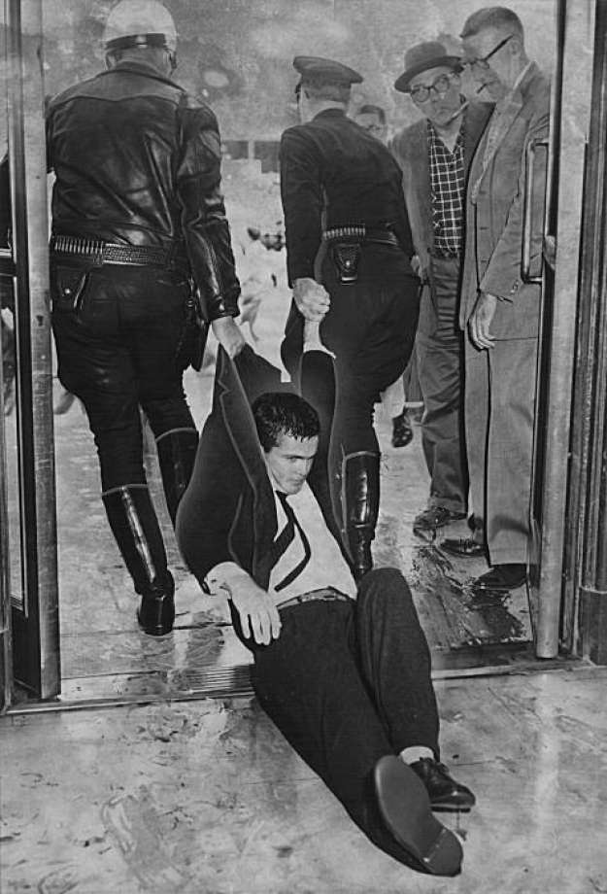
Photo: Archives, 1960, The Chronicle
Two San Francisco police officers drag a young demonstrator out a City Hall door. He was one of 64 people taken to jail. Photo taken May 14, 1960.Two San Francisco police officers drag a young demonstrator out ... more

A couple of dozen graying men and women will gather at noon today in the ornate rotunda of San Francisco's City Hall to remember the day the police turned fire hoses on them, clubbed them and drove them down the building's grand marble staircase.
It is the 50th anniversary of "Black Friday," May 13, 1960, when a demonstration against the House Subcommittee on Un-American Activities turned into a so-called riot.
The protesters are senior citizens now, but in 1960 most of them were college students; 64 of them were arrested and one was tried for hitting a police officer with his own club. But nobody was convicted of anything, and the "riot" may well have changed history.
"It was the first major mass student demonstration in decades. It led directly to the Free Speech Movement in Berkeley in 1964," said Irving Hall, who was a 24-year-old UC Berkeley teaching assistant who had come across the bay for the protest. "It made possible the 1960s in all its variations."
"It was the end of the '50s," said Becky Jenkins, who was a 23-year-old San Francisco State College student then.
The events that day put San Francisco and Berkeley on the map as a center for dissent; it was a major step in the development of what some people call "The Left Coast."
They wanted in
Black Friday was actually the second day of hearings by the House subcommittee, which had been going around the country holding public investigations into Communist infiltration of unions, the film industry and the teaching profession.
Protesters disrupted the first day's hearings, held in the second-floor supervisors City Hall chambers Thursday, May 12. On Friday, the House probers allowed only their supporters into the hearing, pretty much excluding the general public - especially the students, who had come from college campuses around the Bay Area.

The students wanted in. They sat down outside the chambers. They chanted and sang, "We Shall Not Be Moved," an anthem of the civil rights movement.
"It was disruptive," said Hall. Then without warning, Hall said, the police turned on the fire hoses and aimed them at the protesters who were inside at the top of the staircase. "There was no order to move, no reading of the riot act," he said.
Police Inspector Michael Maguire, who was in charge, later said a demonstrator spit on him. Another knocked him down. "Until I got the hoses going it was pretty rough," he said.

"I thought the cops panicked," said Jenkins.
The protesters held their positions at the top of the staircase, standing against the high pressure stream of water "like trees in a hurricane," The Chronicle reported. Then they were washed down the marble staircase, and the police followed, "clubbing demonstrators at will," The Chronicle said.
Marshall Krause, an attorney, who was watching the demonstration, yelled at the police: "Turn that goddamn fire hose off." He was thrown in a patrol wagon and hauled off to jail.
'Wet and bedraggled'
The prisoners were taken to the old Hall of Justice on Kearny Street across from Portsmouth Square.
"And there we were, looking kind of wet and bedraggled," Jenkins remembered. To the authorities, they looked like Communist dupes, but on television and in the newspapers they looked like college kids.
The riot made the front pages of newspapers across the country, and the immediate reaction was shock. FBI Director J. Edgar Hoover said the riot was incited by Communists who got the students to follow the Communist Party line.
Supporters of the House un-American activities subcommittee made a film called "Operation Abolition" that used television footage to show the events were the work of "well-trained and high-profile Communist agents" and the students were "Red dupes."
Even by today's standards, the film was one-sided and so shrill as to be ludicrous. It was shown all over the country to college students, at military installations and American Legion posts. Rep. Francis Walter, D-Pa., chairman of the House committee, estimated that 10 million people had seen "Operation Abolition."
The film had the exact opposite effect of what the filmmakers had in mind.
"It backfired gigantically," Hall said.
It was clear that the demonstrators had a point and the police had overreacted. At their court hearing, San Francisco Judge Albert Axelrod called the protesters "clean-cut American students."
Destination Berkeley
"For a lot of students it was a turning point," said Marty Hittelman, who was in the hearing room that day and is now the president of the California Federation of Teachers. "People saw that film, and said, 'I'm going to Berkeley! I want to be a part of this movement. I want to be a part of change.' "
Black Friday was also a death blow to the House Committee on Un-American Activities. It never held hearings out of Washington, D.C., again.
"We won," said Hall. "We beat the suckers."
The incident wrecked the career of police Inspector Maguire, who ordered the fire hoses turned on. He retired on a disability pension in 1962 after he told the city Retirement Board that the aftermath of the riot had ruined his life.
"They said it was a horrible thing I did," he said. He said he developed what he called a "nervous condition," he got crank calls and obscene letters, and lost all his friends.
He died in 1986 at the age of 69.
'Black Friday' remembered
Commemoration: Noon today at San Francisco's City Hall Rotunda with speakers who were among those arrested on May 13, 1960.
Film: "Operation Abolition" will be shown today at 7:30 p.m. at UC Hastings College of the Law, 198 McAllister St., San Francisco.

