The Misconception about Baby Boomers and the Sixties

**[[](https://www.newyorker.com/contributors/louis-menand)](https://www.newyorker.com/contributors/louis-menand)**

**By** [**Louis Menand**](https://www.newyorker.com/contributors/louis-menand)

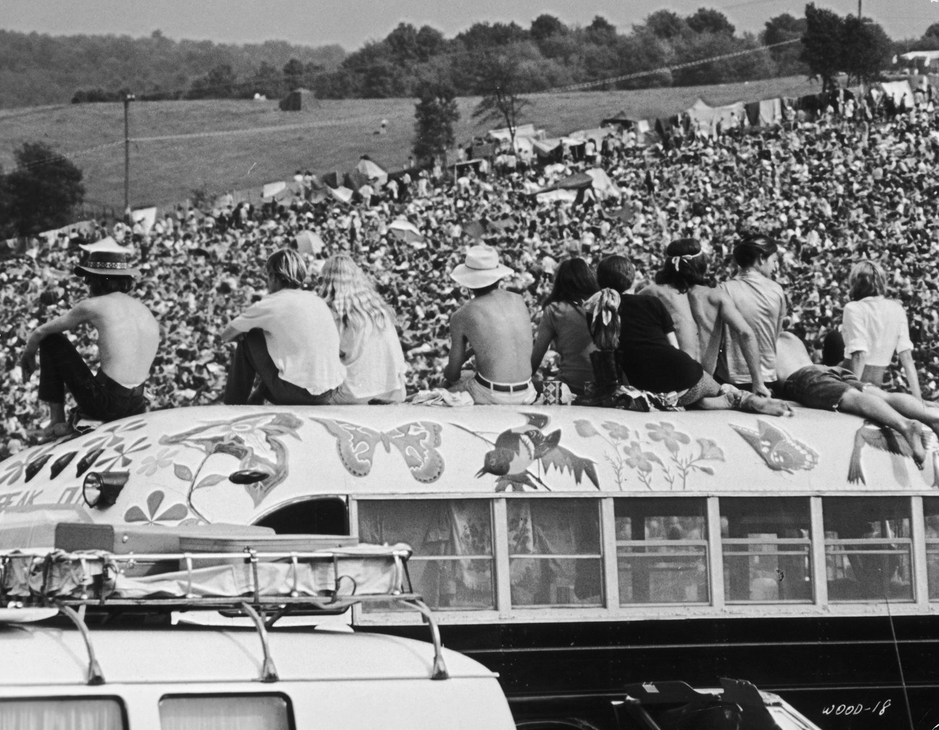

*Conventional wisdom places the boomers at the center of the social and cultural events of the nineteen-sixties, including Woodstock. In truth, they had almost nothing to do with that era.*

Photograph from Getty

Thankfully, we are within sight of the end of the fiftieth anniversaries of things that happened in the [nineteen-sixties](https://www.newyorker.com/tag/the-sixties). What’s left is mostly stuff that no one wants to remember: the Days of Rage, Nixon’s Silent Majority speech, the death of Jack Kerouac, and [Altamont](https://www.newyorker.com/culture/cultural-comment/the-chaos-of-altamont-and-the-murder-of-meredith-hunter)—although these will probably not pass entirely without mention.

One reason to feel glad to be nearly done with this round of fiftieths is that we will no longer be subjected, constantly, to generalizations about the baby-boom generation. There are many canards about that generation, but the most persistent is that the boomers were central to the social and cultural events of the nineteen-sixties. Apart from being alive, baby boomers had almost nothing to do with the nineteen-sixties.

The math is not that hard. **The boom began in July, 1946, when live births in the United States jumped to two hundred and eighty-six thousand, and it did not end until December, 1964**, when three hundred and thirty-one thousand babies were born. That’s eighteen years and approximately seventy-six million people. It does not make a lot of sense to try to generalize about seventy-six million people. The expectations and potential life paths of Americans born in 1946 were completely different from the expectations and life paths of Americans born in 1964. **One cohort entered the workforce in a growing economy, the other in a recession**. One cohort had Elvis Presley to look forward to; the other had him to look back on. **Male forty-sixers had to register for the draft, something people born in 1964 never had to worry about.**

The boomers get tied to the sixties because they are assumed to have created a culture of liberal permissiveness, and because they were utopians—political idealists, social activists, counterculturalists. In fact, **it is almost impossible to name a single person born after 1945 who played any kind of role in the civil-rights movement, Students for a Democratic Society, the New Left, the antiwar movement, or the Black Panthers during the nineteen-sixties. Those movements were all started by older, usually much older, people.**

The baby boomers obviously played no substantive role in the passage of the Civil Rights Act or the Voting Rights Act, or in the decisions of the Warren Court, which are the most important political accomplishments of the decade. Nor were they responsible for the women’s movement or gay liberation. Betty Friedan was born in 1921, Gloria Steinem in 1934. The person conventionally credited with setting off the [Stonewall](https://www.newyorker.com/tag/stonewall) riots, Stormé DeLarverie, was born in 1920.

Even the younger activists in the civil-rights movement were not boomers. John Lewis was born in 1940, Diane Nash in 1938, Bob Moses in 1935. The three activists who were killed during Freedom Summer in Mississippi, in 1964, were all born before 1945. Stokely Carmichael was born in 1941 (in Trinidad and Tobago), Bobby Seale in 1936, Huey Newton in 1942. Malcolm X was born in 1925, four years before Martin Luther King, Jr.

Mario Savio, the de-facto leader of the Berkeley Free Speech Movement, was born before 1945. Tom Hayden, Jerry Rubin, and Abbie Hoffman were all born before 1940. Dennis Hopper, who directed “Easy Rider,” was born in 1936; Mike Nichols, who directed “The Graduate,” was born in 1931 (in Berlin); and Arthur Penn, who directed “Bonnie and Clyde,” was born in 1922.

Virtually every prominent writer and artist in the nineteen-sixties was born before 1940. Allen Ginsberg, James Baldwin, Truman Capote, Flannery O’Connor, Norman Mailer, and Andy Warhol were born in the nineteen-twenties, Carolee Schneemann, Yvonne Rainer, Sylvia Plath, Philip Roth, Amiri Baraka, Ken Kesey, Donald Barthelme, and Tom Wolfe in the nineteen-thirties, as were James Rado and Gerome Ragni, co-authors of the musical “Hair.” The chief promoter of rock and roll, Bill Graham, was born in 1931 (in Berlin). The chief proselytizer for psychedelic drugs, Timothy Leary, was born in 1920. Even Michael Lang, the original Woodstock promoter who can’t seem to quit, was born in 1944. Dr. Seuss was born in 1904.

Almost none of the musicians who were popular during that era were boomers. Bob Dylan, Joan Baez, Jerry Garcia, Janis Joplin, Jimi Hendrix, Jim Morrison, Sly Stone, Frank Zappa, Otis Redding, Lou Reed, Diana Ross, and Paul Simon were all born before 1945. O.K., Stevie Wonder was born in 1950, and Janis Ian was born in 1951. But everyone used to say, “They’re so young!”

Although the boomers may not have contributed much to the social and cultural changes of the nineteen-sixties, many certainly consumed them, embraced them, and identified with them. Still, the peak year of the boom was 1957, when 4.3 million people were born, and those folks did not go to Woodstock. They were twelve years old. Neither did the rest of the 33.5 million people born between 1957 and 1964. They didn’t start even going to high school until 1971. When the youngest boomer graduated from high school, Ronald Reagan was President and the Vietnam War had been over for seven years.

Older boomers do have memories of the politics and the music of the sixties, even if they were pretty peripheral participants. The oldest of them may have marched and occupied and worn flowers in their hair, although the fraction of any generation that engages in radical or countercultural behavior is always very small. A much larger number of young Americans went to Vietnam than dropped out. It follows that most of the people who experienced post-sixties hangovers in the nineteen-seventies were not boomers, either. The whole narrative of postwar U.S. history is demographically skewed.

One reason that it may seem natural to identify young people with what was happening in the nineteen-sixties is because of the huge emphasis in those years on youth—though few at the time seem to have realized that a lot of the people who went around saying “Don’t trust anyone over thirty” were over thirty.

But there was a lot of youth culture in the nineteen-sixties only because there was a lot of youth. The idea that youth culture is culture created by youth is a myth. Youth culture is manufactured by people who are no longer young. When you are actually a young person, you can only consume what’s out there. It often becomes “your culture,” but not because you made it. If you were born during the baby boom, you can call yourself a sixties person. You can even *be* a sixties person. Just don’t pretend that any of it was your idea.

*[[](https://www.newyorker.com/contributors/louis-menand)](https://www.newyorker.com/contributors/louis-menand)*

* *Louis Menand has been a staﬀ writer at The New Yorker since 2001. He was awarded the National Humanities Medal in 2016.*