**Eyes are upon you**

[How DARE you!](https://www.dailykos.com/stories/2019/9/23/1887297/-How-DARE-you)

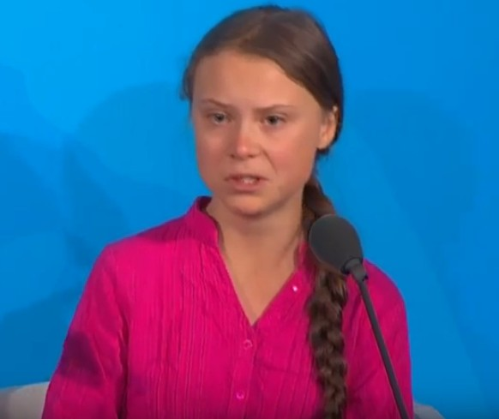

[GretaThunberg](https://www.dailykos.com/news/GretaThunberg)

**How DARE you!**

September 23, 2019 ·

*This is all wrong. I shouldn’t be standing here. I should be back in school on the other side of the ocean. Yet you all come to me for hope? How dare you! You have stolen my dreams and my childhood with your empty words. And yet I’m one of the lucky ones. People are suffering. People are dying. Entire ecosystems are collapsing. We are in the beginning of a mass extinction. And all you can talk about is money and fairytales of eternal economic growth. How dare you!*

*For more than 30 years the science has been crystal clear. How dare you continue to look away, and come here saying that you are doing enough, when the politics and solutions needed are still nowhere in sight.*

*You say you “hear” us and that you understand the urgency. But no matter how sad and angry I am, I don’t want to believe that. Because if you fully understood the situation and still kept on failing to act, then you would be evil. And I refuse to believe that.*

*The popular idea of cutting our emissions in half in 10 years only gives us a 50% chance of staying below 1.5C degrees, and the risk of setting off irreversible chain reactions beyond human control.*

*Maybe 50% is acceptable to you. But those numbers don’t include tipping points, most feedback loops, additional warming hidden by toxic air pollution or the aspects of justice and equity. They also rely on my and my children’s generation sucking hundreds of billions of tonnes of your CO2 out of the air with technologies that barely exist. So a 50% risk is simply not acceptable to us – we who have to live with the consequences.*

*To have a 67% chance of staying below a 1.5C global temperature rise – the best odds given by the Intergovernmental Panel on Climate Change – the world had 420 gigatonnes of carbon dioxide left to emit back on 1 January 2018. Today that figure is already down to less than 350 gigatonnes. How dare you pretend that this can be solved with business-as-usual and some technical solutions. With today’s emissions levels, that remaining CO2 budget will be entirely gone in less than eight and a half years.*

*There will not be any solutions or plans presented in line with these figures today. Because these numbers are too uncomfortable. And you are still not mature enough to tell it like it is.*

*You are failing us. But the young people are starting to understand your betrayal. The eyes of all future generations are upon you. And if you choose to fail us I say we will never forgive you. We will not let you get away with this. Right here, right now is where we draw the line. The world is waking up. And change is coming, whether you like it or not.*

<https://twitter.com/i/status/1176148556345774085>