**The Last Folksinger**

**Ramblin’ Jack Elliott befriended Woody Guthrie, hung out with the Dead, and hit the road with Bob Dylan’s Rolling Thunder Revue. At 88, this self-made cowboy is still on the move**

*By*

[**DAVID BROWNE**](https://www.rollingstone.com/author/david-browne/)

Rolling Stone

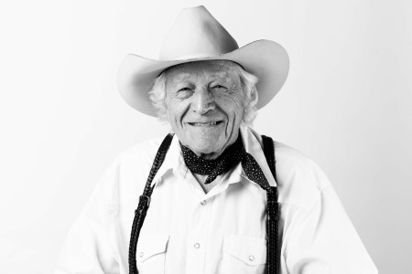

**Self-made cowboy Ramblin' Jack Elliott, maybe the last pre-rock folksinger, shares memories of old friends like Bob Dylan and Woody Guthrie.**

**Michael Avedon**

“Hey, cowboy!”

Even in a city where everyone’s seen it all, the sight of Ramblin’ Jack Elliott is still enough to turn a few heads, including one of a guy plopped down outside a bodega. On a recent summer morning, Elliott has returned to his former stomping, singing, and drinking grounds of New York’s Greenwich Village. As he has most of his life, he resembles a slightly bow-legged ranch hand on a day off — black T-shirt, slightly scuffed black boots, jeans with suspenders that resemble a woven belt. White strands stick out from under his omnipresent cowboy hat, making him look like a noble bald eagle with hair.

**Woody Guthrie, Cisco Houston, Pete Seeger and the other Weavers** — at one time, Elliott was friends and singing buddies with all of them. But at this point, they’re all gone, leaving Elliott, who will turn 88 the day after this walking tour, as probably the last of a generation of American folksingers, the one that preceded the folk boom of the Sixties. An Elliott performance, like the one he gave the night before at nearby club City Winery, is a campfire-ready trip back to the days before rock & roll. Sitting on a chair cradling his guitar, with his hat smushed down on his head, Elliott spends an hour singing songs by Guthrie, [**Bob Dylan**](https://www.rollingstone.com/t/bob-dylan/), and Jesse Fuller, and the traditional “Cuckoo” in the buoyant bark that’s his vocal trademark, peppered with the occasional yodel or holler.

**RELATED**

Each song is preceded by one of Elliott’s endless array of stories, memories, and tall tales, delivered with an occasional dry cackle. The crowd eats up his recounting of his appearance at [**this summer’s Newport Folk Festival**](https://www.rollingstone.com/music/music-live-reviews/newport-folk-fest-2019-recap-864579/), where he almost lost his hearing aids and led a festival-ending sing-along of “Goodnight, Irene.” For that song, his backing band, so to speak, included Brandi Carlile, Colin Meloy of the Decemberists, Rhiannon Giddens, and singer-songwriter and *Hadestown*mastermind Anaïs Mitchell — a lineup that’s in itself a testament to his stature, even though he’s never had a hit record in his life.

1:14

None of which means anything to the guy outside the bodega who jovially but slightly sarcastically hails the “cowboy” who just walked by. He probably thinks Elliott is a tourist from somewhere out West. (Another woman walking by mistakes him for Willie Nelson.) But rather than ignore him and keep walking, Elliott stops, smiles, and asks the guy where he’s from. Chile, it turns out — and Elliott breaks into Spanish and tells a tale about one of his many global adventures, this time in that country. The guy is surprised and disarmed, and his misgivings seem to melt away.

When he’s informed he had just spoken with the famous Ramblin’ Jack Elliott, the name doesn’t register. But Elliott’s rubbery face breaks out into a smile. “Used to be famous,” he says. “Now I’m retired. *Tryin’*to quit.”

**Given the times he’s intersected** with many of our most monumental figures, Ramblin’ Jack Elliott may be the closest thing we have to a Zelig of American music. He was a mentor to Dylan and a pal of everyone from Sam Shepard to Willie Nelson. He traveled the country with Guthrie, jammed with blues legends Sonny Terry and Brownie McGhee, backed Nico during her post–Velvet Underground club days, and partook of Dylan’s [**Rolling Thunder Revue**](https://www.rollingstone.com/t/rolling-thunder-revue/) (one of his performances can be seen in Martin Scorsese’s [**recent doc on the tour**](https://www.rollingstone.com/movies/movie-features/the-inside-story-of-bob-dylan-martin-scorseses-rolling-thunder-revue-doc-844268/)). His reinvention — the way he transformed himself from the son of a Jewish doctor into an utterly secular all-American cowboy — set the template for so many who’ve undergone similar makeovers.

These days, especially, Elliott feels like one of the last connections to an increasingly vanishing world. “Right, and the purest,” says [**Bob Weir**](https://www.rollingstone.com/t/bob-weir/), who has known Elliott since the Sixties. “He’s a self-architectured, hand-built American icon. He’s a Jewish kid from New York City who decided he wanted to be a cowboy. He’s maybe the last guy of that ilk who actually went ahead and did that and made it stick. I don’t know if he rode the rodeo, but I wouldn’t be surprised if he *had*.”

He was indeed born Elliot Charles Adnopoz, the son of a doctor and surgeon, in August 1931. Starting around the age of nine, he attended rodeo shows at New York’s Madison Square Garden and at 15 left home “to be a cowboy, but I didn’t have any sort of plan. I just left home.” In another tradition that now feels as Old World as his repertoire, he literally joined the circus in Washington, D.C., where he watched one of the clowns play guitar and banjo to entertain the stagehands. “That was my first real experience of real live folk music,” he says. “We’d put a quarter in his hat.”

Thanks to his desperate parents, who actually distributed fliers with photos of their missing child, Elliott returned home but would soon again be lured away. He began singing and playing guitar, at first calling himself Chuck Adnopoz (“I thought that sounded *cool*”) before opting for Buck Elliott. The transformation was eventually completed by way of his friend **Odetta,** the folksinger. Visiting her one day, Elliott, who was already known for his long and winding storytelling, knocked on her door and, on the other side of it, heard her mother say, “That ramblin’ Jack is here!” The name stuck.

Elliott had heard Woody Guthrie’s songs on a Folkways album, *Struggle: Documentary #1,* and obtained his number from Tom Paley of the **New Lost City Ramblers**. Elliott somehow summoned up the nerve to call Guthrie, who also lived in Brooklyn. “Listening to the voice of the man I’d been listening to on the record, that was a thrill in itself,” he recalls. “I said, ‘Woody, my name is Buck Elliott, I’m a friend of Tom Paley’s. I’ve been listening to your records and I’ve been playing guitar for about four years.’ ‘Well,’ he says, ‘Jack, ya oughta come over and bring your *gi*-tar and we’ll knock off a couple of tunes together. Don’t come today, though — I gotta belly ache.’”

Elliott ended up meeting Guthrie for the first time at a hospital, when Guthrie was recovering from appendicitis and was still, Elliott says, “pretty dopey.” He strummed a few chords and Guthrie mumbled, “Better not make any noise.” Guthrie’s wife Marjorie gave Elliott a tour of their apartment on Mermaid Avenue in Brooklyn, where Elliott saw Guthrie’s iconic “This Machine Kills Fascists” guitar on the wall.

Soon enough, Elliott became a recurring character in the Guthrie home, where one of Woody’s children, Arlo, had an early glimpse of Elliott’s idiosyncrasies. Guthrie remembers being in school in Brooklyn when Elliott showed up in a telephone-repair truck converted into a camper. “This was before people had campers,” Guthrie told *RS*in an interview in 2009. “And every jaw in that entire school dropped. I remember all the faces of the kids, saying, ‘You *know*that guy?’ He really provided a free spirit.”

Arlo equally recalls Elliott as the guy who would appear at the Guthrie home behind the wheel of a Motel T Ford and take the Guthrie kids for long drive. During one ride out to Long Island, he noticed Elliott would stop periodically to buy 25 cents’ worth of gas. “I couldn’t figure out what he was doing — why not just fill the tank?” Guthrie says. “I didn’t understand. Why did he have to talk to everybody along the way? He just loved telling and hearing stories. He was uninhibited when it came to meeting people.”

But Elliott’s adventures were just beginning. When Woody Guthrie left his family in 1950, dismayed by early signs of the neurological disorder (Huntington’s Chorea) that would eventually take his life, Elliott tagged along and wound up traveling with him to California and Florida. “I never really did talk to my dad about it, but I think my dad loved that he had a sidekick,” Arlo says. “That was really Jack’s role. He took care of my dad. At that time, my dad was showing the first signs of being ill with Huntington’s. He walked like he was drunk. He didn’t have the balance he had as a young man. Jack was somebody who my dad felt comfortable with, but who would also look out for him.”

In California, Guthrie met Anneke Van Kirk, who would become his next wife, and Elliott recalls the tension that resulted when he and Van Kirk would converse. “Woody got more and more grumpy because I was 22 and she was 21,” he says. “It made Woody *nervous*. He was my hero! I wouldn’t have looked at his wife. But he felt ill at ease about it and I got the feeling that maybe I oughta take off.”

By the mid-Fifties, Elliott had relocated to England where, legend has it, he busked for a group of kids that included **Mick Jagger and Keith Richards**. (Jagger has since said that he bought his first guitar after hearing Elliott.) Returning to America in 1961, Elliott went straight from his ship to a New Jersey hospital, where Guthrie was in increasingly bad shape. “The disease was starting to get to him,” Elliott recalls. “He was losing his ability to speak clearly. You had to be very patient and ask him to repeat three or four times to understand what he said.”

With Guthrie ailing, Elliott became the prime ambassador of his music, singing Guthrie’s songs in a similar style. If you wanted to hear “This Land Is Your Land,” “Hard Travelin’,” or so many other Guthrie standards back then, Elliott was the destination, both live and on his earliest albums. When Guthrie died in 1967, Elliott, then in his mid-thirties, became one of folk’s elder statesmen and Guthrie’s non-family heir. “My dad once said of Jack, ‘He sounds more like me than I do!’” Arlo says. “Jack brought an authenticity to the songs. It would be a shame to say he was just a mimic of Woody because frankly he could mimic anyone. You listen to Jack’s Scottish brogue when he sings old Scottish songs and it’s just true.”

For a moment in the Sixties, Elliott seemed on the brink of some sort of crossover fame. He signed to Warner Bros., which released one of his strongest albums, *Young Brigham*, where he covered the Stones’ “Connection” and Tim Hardin’s “If I Were a Carpenter,” and he appeared on Johnny Cash’s network TV show. But going pop was the last thing on Elliott’s agenda. “I’ve never heard any attempt at commerciality on his part,” says singer-songwriter Todd Snider, who met Elliott in the Nineties. “I don’t think he ever got drawn into that. I don’t think money meant shit to him.”

That was especially true with *Young Brigham*, the cover of which showed Elliott astride a horse of the same name. (“I couldn’t have thought of my dad as any more of a cowboy,” recalls his daughter Aiyana Elliott, born around this time. “My first name for him was ‘horse man.’ From a young age, he’d put you on a horse.”) The guy who sold him the animal told Elliott that if he put Brigham on the cover of the album, the hay to feed him would be tax-deductible. Elliott went along with the plan, but then failed to use the tax deduction.

**As he traverses the Village,**another part of Elliott’s past emerges when he finds himself in front of the Bitter End, the enduring Bleecker Street club that once opened its doors to early performances by everyone from Joni Mitchell and Neil Young to Woody Allen. Elliott remembers the time in 1975 when Dylan and Patti Smith both appeared at one of his gigs. “They said, ‘We’re thinking about doing a tour and playing these little theaters,’” he says. “I said, ‘Sounds like a good idea.’” Soon enough, Elliott was part of the traveling gypsy hootenanny known as the Rolling Thunder Revue.

Dylan and Guthrie have crossed paths numerous times over decades, shifting roles along the way. They met in Woody Guthrie’s hospital room in 1961, right when Elliott had returned from England. Dylan clearly idolized Guthrie but Elliott as well; in *Chronicles, Volume One*, Dylan recalls Elliott as “a brilliant entertainer” who was “so confident it makes me sick.” Dylan told Elliott at the time that he had all his albums and rattled off the names of specific songs, and Dylan ended up moving into the same Village hotel where Elliot was living; Elliott helped him get his cabaret license so the kid could perform in the city.

“Dylan had the same background, in a sense,” Arlo Guthrie says. “Came from a Jewish family. Also changed his name, changed his background. How much of that is symbiotic? But the history is oddly familiar. [With Elliott] you see in somebody the possibilities for you, even if you’re not thinking in those terms. It opens the doors to potentials that didn’t exist.”

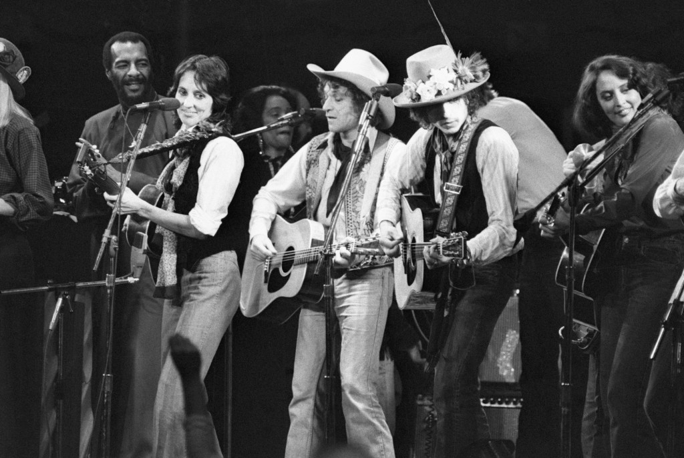

**Richie Havens, Joan Baez, Ramblin’ Jack Elliott, Bob Dylan, and others perform at a benefit concert for Rubin “Hurricane” Carter.  
Photo by Bettmann Archive**

Running into Dylan on the street in 1964, Elliott was invited along to the recording sessions for *Another Side of Bob Dylan*; there, they cut an early version of “Mr. Tambourine Man,” with Elliott singing along despite not knowing all the words. A tape of that performance made it to the Byrds, and even though Roger McGuinn says Elliott’s harmony was “quite out of tune,” it helped prompt the band to add harmonies on their own version of the song. Elliott also stored his motorcycle in the same Woodstock barn where Dylan stashed his own, likely the same one that resulted in his catastrophic accident in 1967.

Elliott says he saw a Dylan show not long ago and recounts the story, complete with a spot-on Bob impersonation: “I went back and said, ‘Hey, Bob, I love ya.’ He said, ‘I love ya, Jack.’ He never told me that before. I never told him that either.” The two had a quick conversation, Dylan asking an elliptical question about the late banjo player Billy Faier before retreating to his tour bus. Elliott was able to spend more time with Dylan’s son Jakob, whose band the Wallflowers were playing another room in City Winery the same night Elliott was there. “Talked about his dad a little bit,” Elliott says. “I don’t think he knew some of those stories. He agreed that Bob is kind of a weird guy.” He said that? “Not in those particular words,” Elliott replies, “but he was very sim*pati*co.”

But that night in 1975 when Dylan invited him on tour is fresh on Elliott’s mind, especially given his cameo in Scorsese’s *Rolling Thunder Revue* doc. “I don’t remember being that intense,” Elliott says of the vintage footage, in which he definitely seems wired. “There was a little too much whiskey involved. Everyone was drunk the whole time. It was very surreal and extremely wasteful of energy and people — they were just thrilled to be able to have the opportunity to go on like a vacation. After 31 days, though, our brains were fried.”

Starting with the exact number of shows, Elliott recalls the adventure well, even if he doesn’t know what to make of the [**fictionalized parts**](https://www.rollingstone.com/movies/movie-news/rolling-thunder-revue-bob-dylan-story-doc-whats-fake-847231/) of Scorsese’s project. “It was like a bunch of kids who’d run away with the circus,” he says of the tour overall. “They’d never tell us what town we were going to. We’d find out minutes after we got there. It was a big military secret. We were coddled and protected and it was kind of fun; it was like being a kid again. We probably had too much to drink and it seemed like we had a lot of rollicking fun the whole way.”

During Rolling Thunder, Elliott lent a cowboy hat to Sam Shepard, tooled around in Dylan’s motorhome while both smoked weed, watched Joni Mitchell write “Coyote” in the back of a bus as they took note of a fire outside the window, and filmed a few unused scenes for *Renaldo & Clara*, the truly odd film that emerged from the tour. “That was a strange movie,” Elliott says. “It had no theme, no plot, no nothin’. I went in the bathroom and had to extemporaneously make up something on the spot. I was playing with the handles on the sink, turning the water on and off. I pretended the water was a truck engine and I was driving a truck. They just kept shootin’ it. After about five minutes, I said, ‘You’re wasting a lot of film.’ They acted like I thought I was Charlie Chaplin.” Another outtake, he says, includes a bit featuring him and **Kris Kristofferson**.

Elliott’s wild ride extended to Marin County, where he wound up moving around the same time. Elliott had met Bob Weir when the teenaged pre-Dead guitarist literally crashed one of his gigs. Climbing through a skylight when he couldn’t get a ticket, Weir found himself in Elliott’s dressing room, where Elliott began talking to Weir as if they’d already met and were in the midst of a conversation. “I discovered *very*quickly why they call him Ramblin’ Jack,” Weir chuckles.

By the Seventies, Elliott had become so integrated into the Dead scene, by way of a shared manager, that he had his own mail slot in the band’s San Rafael office, right next to Weir’s and Jerry Garcia’s. “He was one of the family,” says Weir, “and he earned a lot of love and respect in our family, and well deserved. He didn’t fit in in any possible way, but none of us did.”

Legend has it that the Dead considered signing Elliott to their ill-fated Grateful Dead Records, and Elliott recalls Weir overseeing a recording of “San Francisco Bay Blues” at Weir’s home studio. But none of those recordings have been found in the Dead’s vault. Elliott’s daughter Aiyana, then about five or six, remembers spending time with her dad and the Dead in a studio and getting a surprise Easter basket at the studio, containing a toy bunny and a box of Special K cereal. She calls her father “the ultimate psychedelic cowboy, a hippie cowboy.”

By then, Elliott admits he was partying as much as anybody. “That probably was the druggiest period of my life,” he says. “I was almost addicted to cocaine. I don’t think I was really addicted, but I was doing quite a lot of it back then. And if I kept on, I wouldn’t be here now.” Adds Arlo Guthrie, “He went through some tough times, the normal things in life, drinkin’ a little too much or something like that.”

By the Eighties, Elliott was still on the move, living in Texas (a period chronicled in a new documentary, *Ramblin’ Jack Elliott — A Texas Ramble*). But he stopped recording, burned by the lack of royalties he received from record companies, and he didn’t release another record until the following decade. By then, though, the public was finally starting to catch up with him. His 1998 album *Friends of Mine*included duets with **Weir, Emmylou Harris, John Prine, and Tom Waits**, and Bill Clinton awarded him the Presidential Medal of the Arts the same year.

Yet he remained very much Ramblin’ Jack, the charming, wanderlusting rogue who would ultimately marry five times. In the mid-Nineties, Todd Snider had just released his debut album, and one night in Austin, he found himself in a hotel room talking, drinking, and singing with Jerry Jeff Walker and Elliott, then well into his sixties. “When we ran out of beer, we went and walked up and down the hall until we found a party,” Snider recalls. “No cocaine, just drinking. The sun was coming up on Sixth Street, and we found a breakfast place that served us beer. Jack could stay up all night and never be drunk-looking and still tell stories. He played as good at 4:30 in the morning as he did at 11 at night.” Elliott, he surprised, is “more than a musician — he’s almost a way of life.”

**Outside the Bitter End,** Elliott spies a gray van parked across the street. “I wish I had something like that,” he says with a morning-after forlornness. “I used to have a motorhome, but it burned down.”

During the past two decades, Elliott has faced some tough times. In 2001, his fifth wife Janice died. “It was kind of a heavy deal,” he says somberly. “I had to play a week after that, opening for Merle Haggard. Of course, Merle was very sympathetic, although he was a very shy person. I said, ‘Thank you for having me on the gig.’ I told him what happened and he stared into his coffee and said, ‘I can’t imagine what it would be like to have a spouse die.’ This great songwriter muttering these words into his coffee!”

Soon after, the motorhome where Elliott was living caught fire and burned. These days, he rents a small home in west Marin County, a place so unassuming that fans who recently visited it told the landlord they were shocked that Elliott lived in “a slum,” as they called it.

Elliott wishes he could spend more time there, with the “cows in the backyard and the oysters in the front.” But even as he approaches 90, the road beckons whether he wants it to or not. Backstage at City Winery, he’s asked what he still gets out of live performance and touring. “*Money*,” he says, with a whiff of disgust in his voice. “Simple as that. I can’t retire. If I could afford to retire, I would’ve retired *today*.” In moments like that, he practically spits out his syllables, but in a flash, the bitterness passes.

“The sad story of Jack’s life is that as influential as he’s been, he didn’t write that many songs, so he’s been a total flop at finding ways to monetize what he does,” says Aiyana, who made an acclaimed and poignant doc about her sometimes wayward father, *The Ballad of Ramblin’ Jack*, in 2000. “He can make a little from a gig, but it’s been very challenging. On the other hand, in so many ways he’s lived a charmed and enviable life. He seems blessed with a crazy sort of luck.”

Elliott’s next round of roadwork begins October 10th, when he and Snider kick off a month-long series of shows mostly out West. On touring in general, Aiyana worries about the wear and tear on her father, especially after he drove himself to a show from his northern California home to Portland last year. “I started to feel like this is crazy for him to be out there with no road support,” she says. “It’s probably been crazy all along, but at 88, let’s make sure we have a road manager.” Elliott now has someone accompany him, including Rick Robbins, his loyal and dedicated road manager, who coincidentally grew up with Arlo Guthrie.

Ten years ago, Elliott hit a late-period artistic high with *A Stranger Here*; on it, producer Joe Henry replaced Elliott’s tried-and-true voice-and-guitar approach with more-textured, Old West–saloon arrangements that came off like peak-era Randy Newman. The album won a Grammy in the Traditional Blues Album category, but so far there has been no follow-up. Elliott just lent his voice to an upcoming album by singer and keyboardist Matt Rollings, on which he and Willie Nelson, another longtime pal, join in on Lyle Lovett’s “If I Had a Boat” and the Forties pop hit “That Lucky Old Sun.” But a new studio album may or may not arrive.

With the help of producer Roy Rogers, though, Elliott has started putting his buckets of stories on tape. He already has at least 10 hours recorded, although what will become of them is still being worked out. “There’s a lot of bullshit and I think showbiz is partly based on bullshit,” he says, leaning forward. “But there’s *bad*bullshit and there’s *good*bullshit. And I specialize in *good*bullshit.” 

**“Hello—anybody home?”**

Elliott comes upon the familiar metal stairs that once led down to the Gaslight, another of the Village’s landmark folk clubs. In his telling, Elliott was singing “Don’t Think Twice, It’s All Right” at the Gaslight around 1964 when Dylan was in the audience; impressed with Elliott’s rendition, Dylan stood up and proclaimed, “I relinquish it to you, Jack.” Elliott doesn’t sing the song very often anymore; thanks to a minor stroke a year and a half ago, it’s harder for him to fingerpick. (“That was slightly heartbreaking,” says Aiyana of watching her dad try to play the song recently.)

As with so many of his old haunts, the spot is now another business entirely — a swanky cocktail bar, in this case — and an employee of the place emerges to deal with the old guy who wandered in.

“Hi, I’m Jack Elliott,” Elliott says jovially. “This used to be the Gaslight, right?”

The guy doesn’t know how to answer, telling him the place isn’t yet open for the day, but Elliott continues. “I used to sing here. There was a picture of a man’s smiling face on the wall there. I came here one afternoon and Johnny Cash was singing.”

The employee is patient but clearly doesn’t know what Elliott is talking about, and he says his boss won’t allow anyone into the place yet.

Eventually, Elliott takes the hint.

“Have a nice day,” he says, and walks back up to the street.